Capstone Project Summary - Section C

Program: Java Interface – Slab Inventory Trailer

Class Design:

Database Table Structure/Relationships:

AddOnPrices Stores the pricing information for the two types of slabs. Pricing uses data input into the SlabEntry table and the AddOnPrices Data to present accurate dynamic pricing information. Once the slab is sold, the price information, sale date, and customer that purchased it. The data is saved in a static form to preserve accurate sale history. If a Slab is sold and then later put back into the SlabEntry table, the prices will be recalculated. There is also a Password table that holds a single row that is used for the admin password. It can be changed through the utilities tab in the GUI. The Password is mainly to make data entry personnel think before they take an action that can possibly change data in an undesirable way.

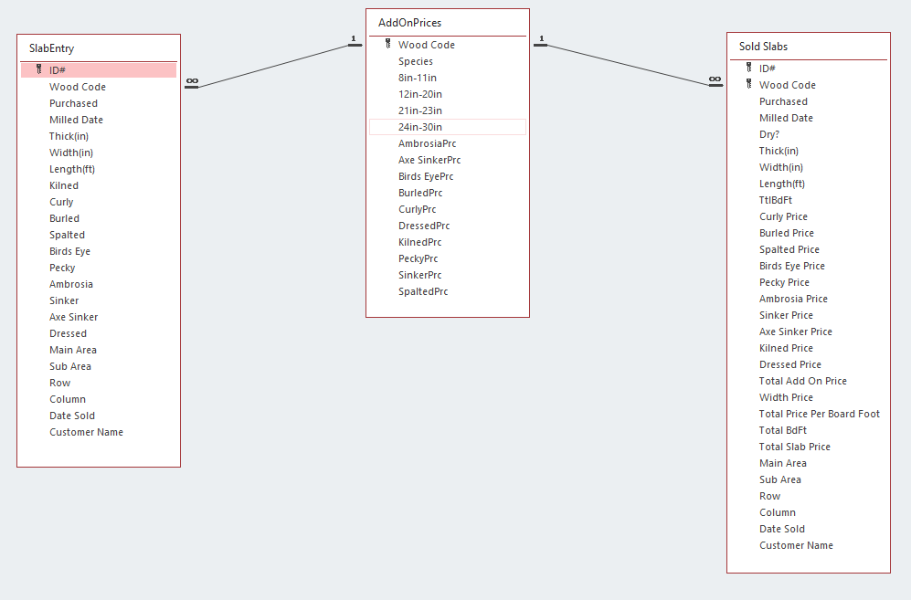

UML For Objects Package:

The InStockSlab class reflects the SlabEntry table, the SoldSlab class reflects the Sold Slabs table. The both extend the Wood class. The Species class reflects the AddOnPrices table.

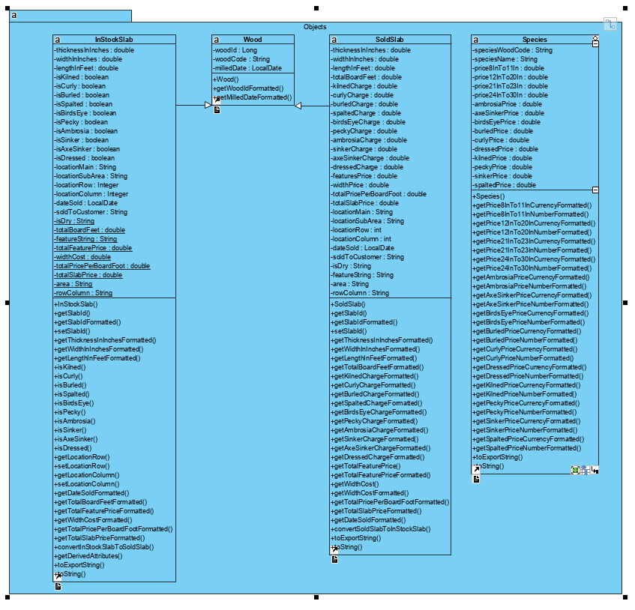

UML Design for Database Package:

The DAO class handles SQL language structuring to communicate with the database from the interface. DBConnector handles connecting the database to the interface using the UCANACCESS API. The Statement maker handles the creation of actual statements to the database.

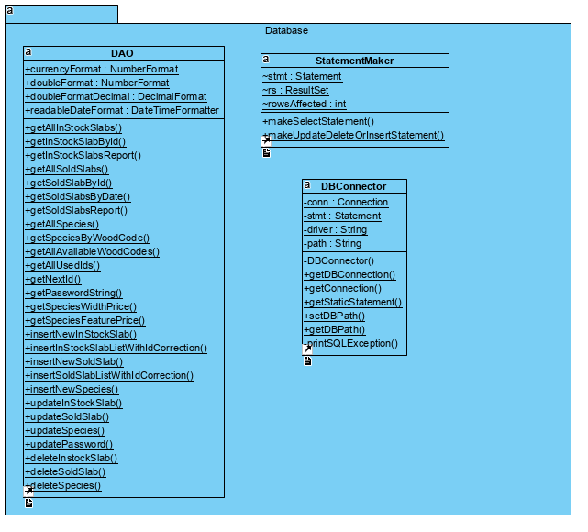

UML Design for Utilities Package:

These FileHandler handles text file IO and MeasurementsParser assist with reading measurements from the filter combo boxes. The SampleData class was used to create dummy data to test the system.

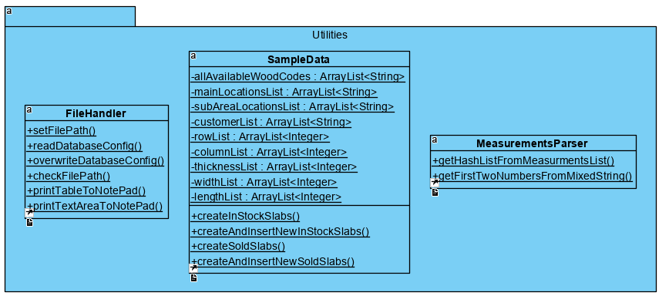

UML Design For GUIs Package:

The SlabTracker class is the main interaction screen for the database. Because of the 5 tabs, this is a very long diagram. Each tab has several control objects and many of them have functions and input validation to go with it. The DatabaseLaunchWindow is the opening database connection screen.

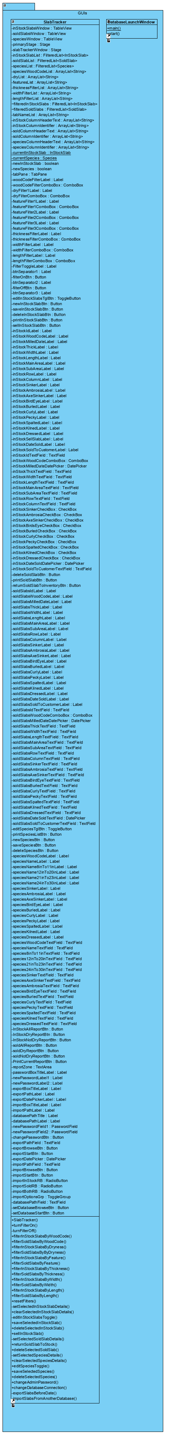

Design Diagrams:

Launch Window Connection: This screen is for connection to a database with the proper structure. Login Credentials were not wanted by the client.

Wireframe:

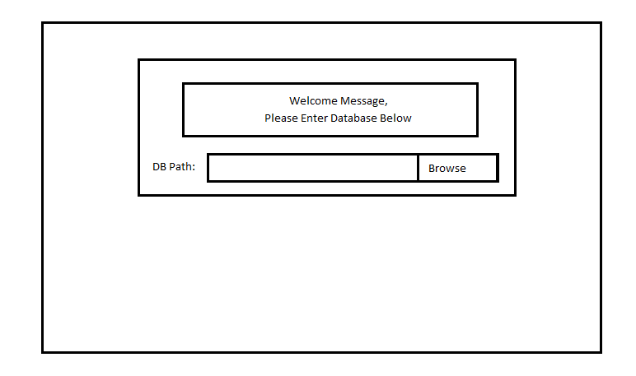

Actual:

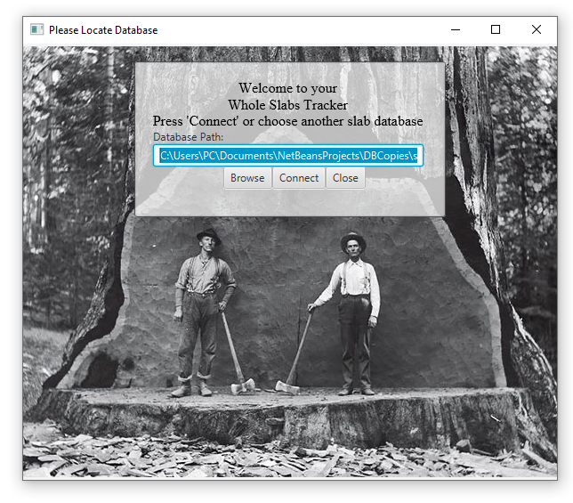

Slab Tracker Window:

Wire Frames:

Data Input Screens (In-Stock, Sold, &Species):

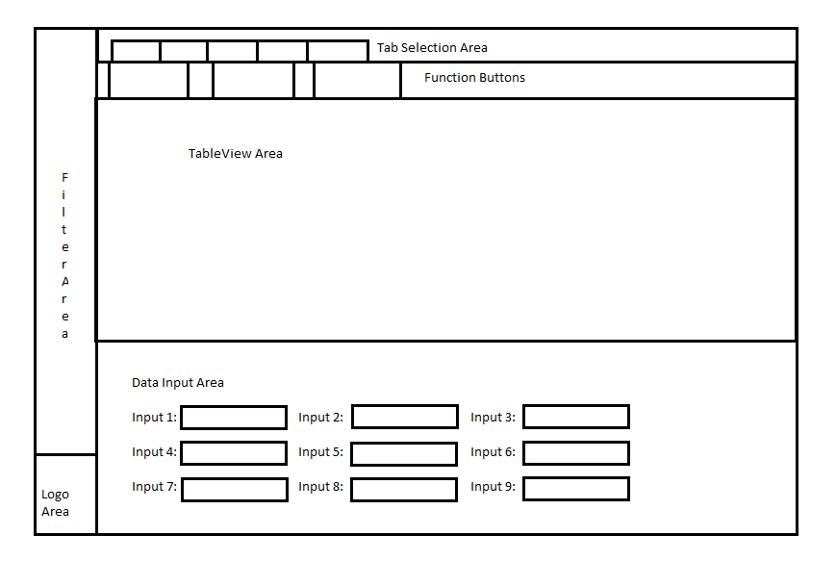

Reports:

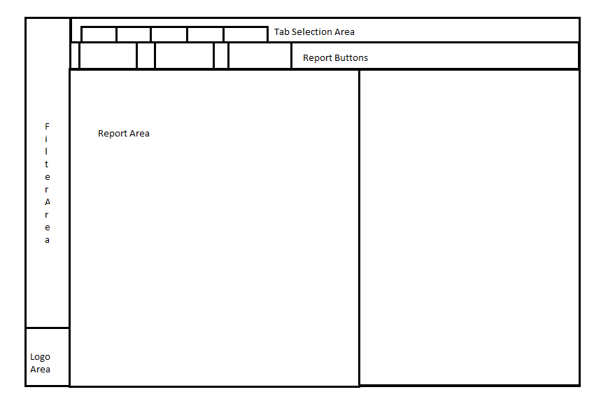

Utilities:

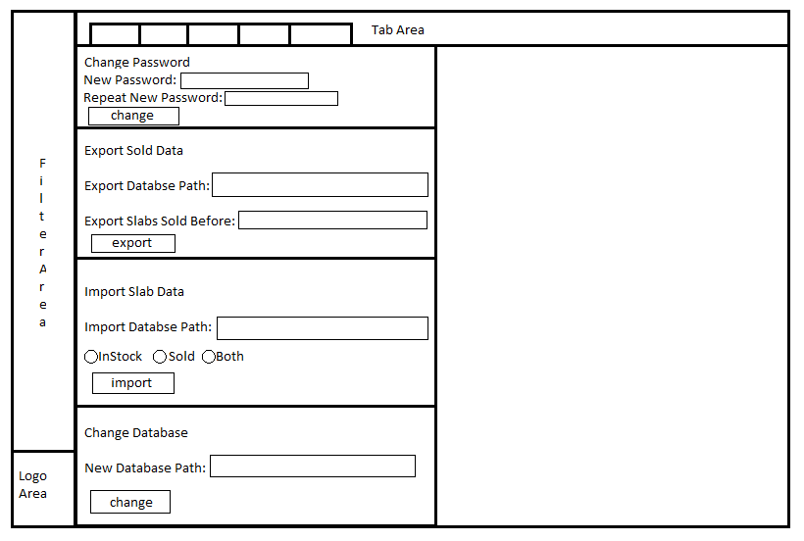

Actuals:

Data Input Screens:

In-Stock:

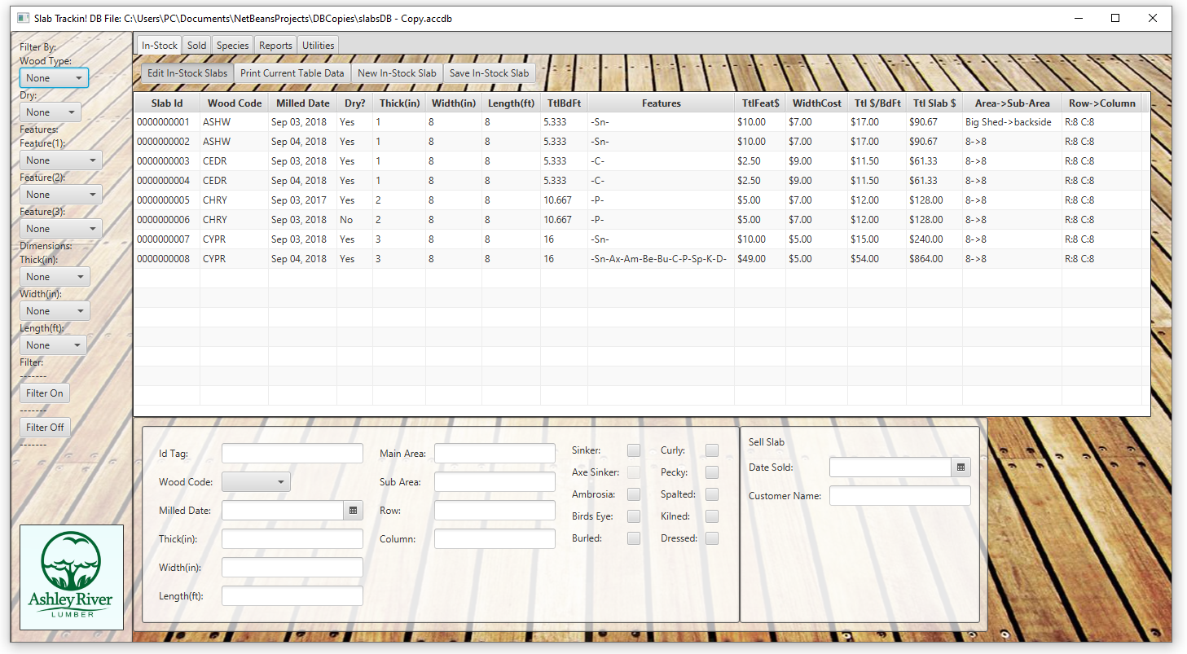

Sold:

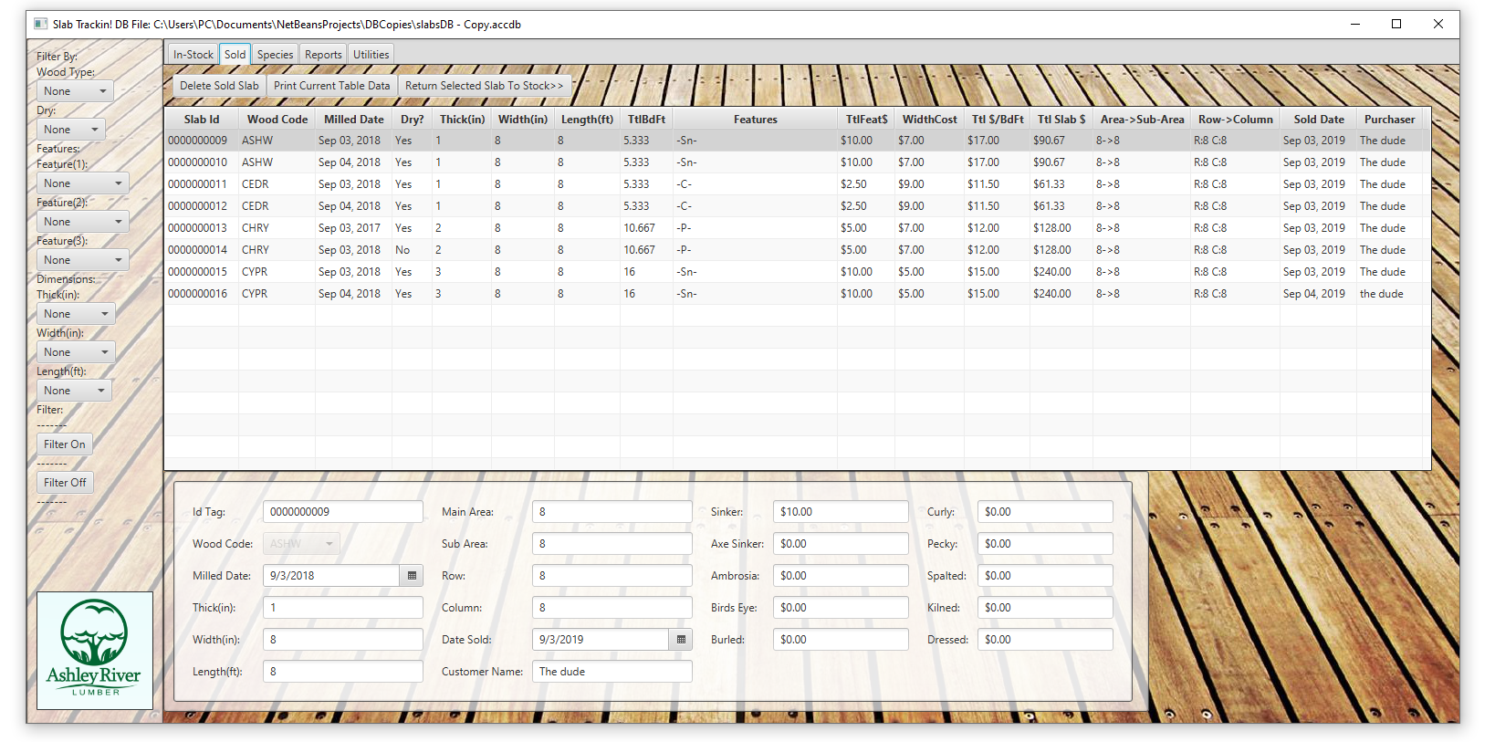

Species:

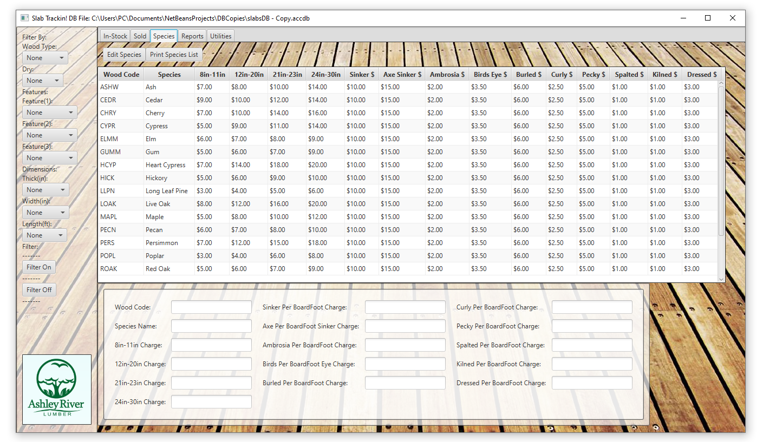

Reports:

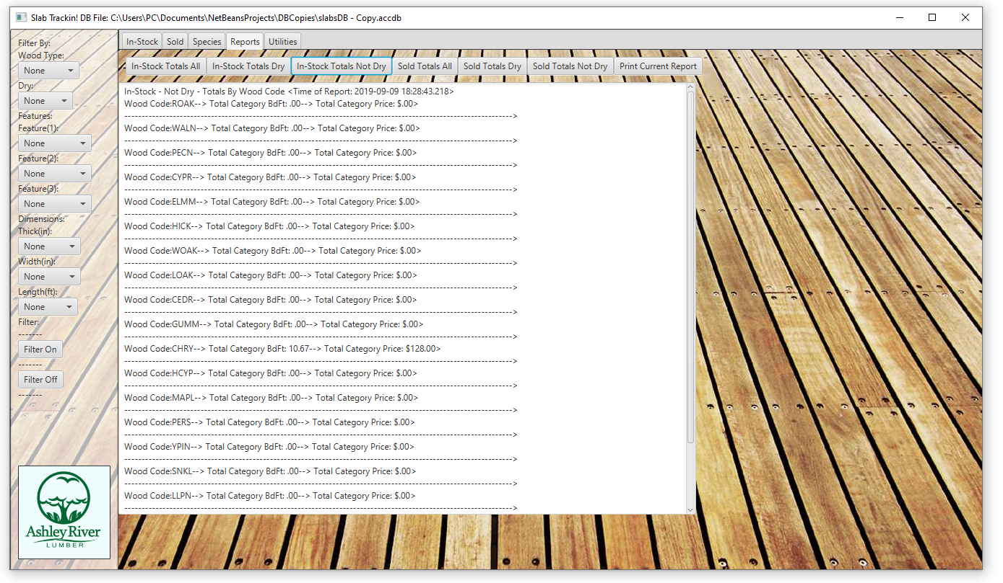

Utilities:

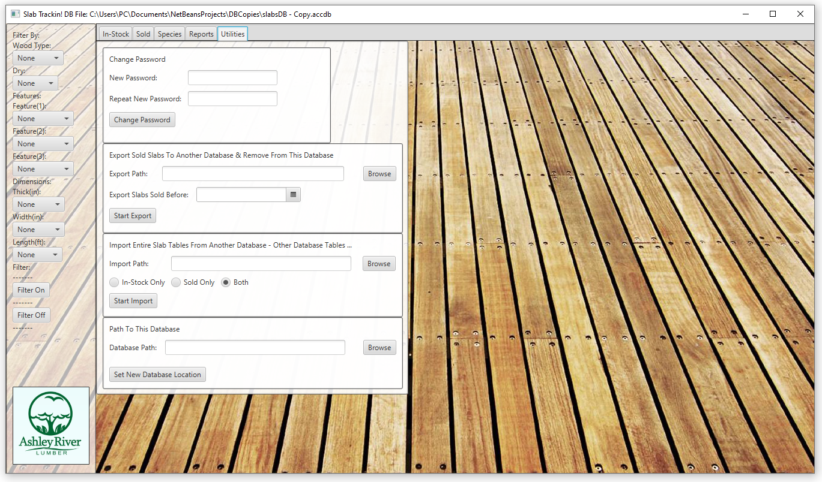

Methodology & Unit Testing:

Overview:

I performed several unit tests to determine that the software was working properly.  I feel that it is best to include a few screenshots of test results as I explain the methodology. First, I tested individual slab insertion and slab variable modification. This ensured that the input data was saved correctly, that the input validation worked correctly, and that modifying the objects also validated and saved the desired information.  I also tested whether the function that derived pricing information, dimensional information and slab dryness were properly calculating the values from the input In-Stock slab data.

Once I had confirmed proper object creation and insertion to the database, I created the SampleData class to assist with creating large amounts of objects to insert.  The SampleData class’ main purpose was to first create sample In-Stock or Sold slabs and then insert them into the database. The slabs that were created used ArrayLists that held variable data for potential objects.  All lists were iterated through using the modulus operator and the size of the variable list so that variables would be filled out differently for each object created. This allowed me to create as many objects as I wanted and insert them.  You can see the SampleData methods used in the SlabTracker code on lines 328 and 329:

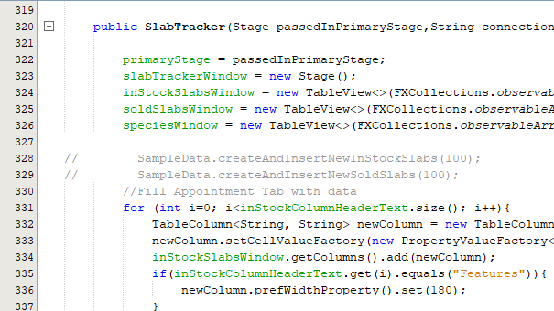

I then performed a stress test and inserted 20,000 objects to ensure database size was in the desired range as well as performance and reaction time. Once I had done this, I moved on to checking filter functions. With large amounts of data available to me I was able to do this without having to create each individual slab which saved me a lot of time.  Filters are applied simultaneously to the In-Stock table and the Sold table. You simply select the filters you want and the click the Filter On button. The Filter Off button returns all table data to both tables. I then created the reports tab to show pricing and board feet summation data by type of wood code table total. This report also totals for the In-Stock table and the Sold table. This is an example of In-Stock Dry Table report:

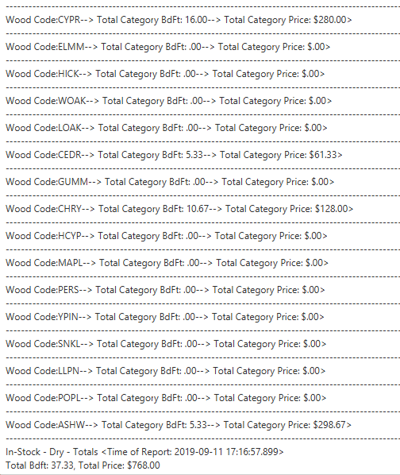

I then created the Utilities page that allows the user to change password, change database, export sold slabs data by date, and import sold and in-stock data from another database. The password changing is pretty standard, but I think it is important to remember this is not as much a security precaution as it is a think before your delete an object or return an slab (this makes the historical price inaccurate possibly). All prices in the In-Stock table are calculated from the In-Stock object variables as needed for up to date pricing. Once the slab is put into the sold category, nothing can be changed about it. This allows the sales record to be accurate.

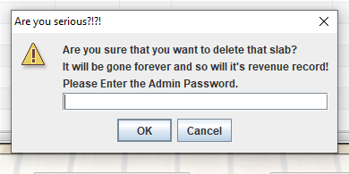

The export function is used for clearing out old sales data. Sometimes businesses only want the current years sales to be together or the database may become full at some point. This function allows the user to remove the slabs from one table and move them to an archive database. This way the customer chooses how they store there records. If the database is a copy of the SlabsDB file, this will work. Since the slab Id is the key for the slabs tables, if you try to export slabs that have the same keys slabs in the other database, the program gives the option to automatically change the slabs or cancel and change the ID’s manually. The import feature also does this.

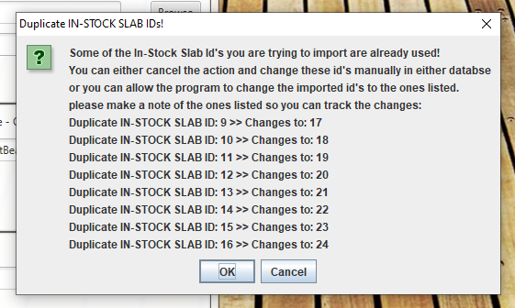

The import function allows the user to import data from another database but doesn’t delete it from the other database. The client had not specified the behavior for this function so I decided non-destructive was better than destructive.

There are print features for All three object tables and the reports table. The program basically takes the table data and writes it to a txt file in the SlabTrackerResources folder. This allows the user to print off table data from the txt file that the program opens in Notepad. The most useful application of the print function is printing off slabs wanted by customers and taking the printed list to check if the location is accurate in the lumber yard. This was a feature that was asked for by the client. First, the program erases the previous data text file then writes a new one. This ensures that each printout is fresh. The program will also create the SlabTrackerResources folder if it is not present. Along with the dbConfig.txt file that save the last known location of the database.

Initial data input:

I then began to unit test each button function in each screen to ensure they behaved as expected.  This included many, many tests. One of the most important parts of the program is to ensure data integrity when moving a slab between In-Stock and Sold tables. I started out with 8 slabs in the In-Stock table. I made them varying with varying characteristics. I had already edge tested the Dry algorithm. This algorithm determines dryness of slab by thickness, feature and time since milling. If a slab is not a sinker, then the number of year to until it is dry is equal to the thickness in inches. If a slab is 2 inches thick, it takes two years to dry. If a slab is a sinker, a log that was submerged under water for a number of years, then it takes one year to dry across the board. This is shown in the picture below:

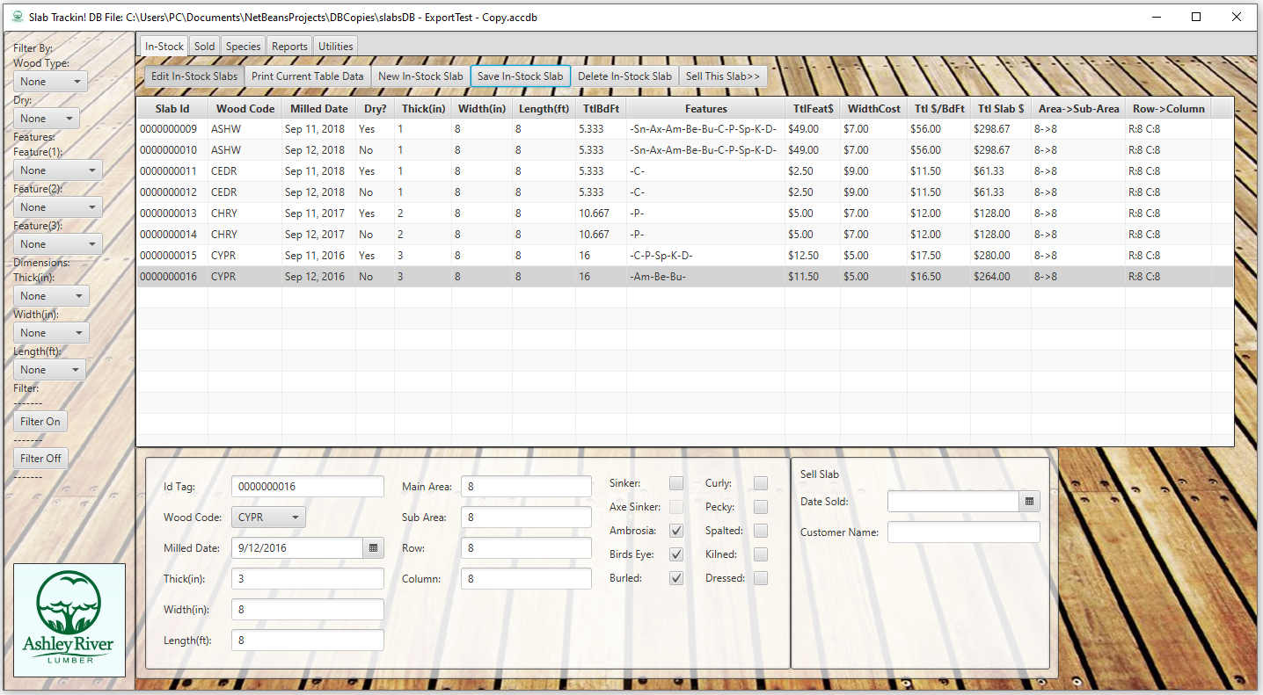

As you can see, there are a lot of input fields. Input validation was used for the In-Stock table and the Species table. Any fields that required an integer or double had a check to ensure the input could be caste into these datatypes. The Id tags for the mill are all ten digits so I was asked to make the Ids appear to have leading zeroes if the id was not ten digits long. The wood code combo box pulls its list directly from the species wood code column. The only field that is allowed to be empty is the Sub Area text field. The only range constraints were for dimensions (thickness, width, and length). The ranges were determined by the customer. If you check the filter combo boxes, you will see that they reflect the ranges for the input checks in the saveInStockSlab method that starts on line 1372 of the SlabTracker class.

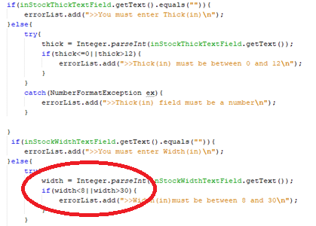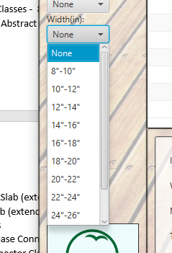

If you don’t fill out the fields correctly the program lets you know what needs to be done before the slab can be saved. This is true for any data input including selling slab (the Date Sold and Customer Name Field) as well as the data input for the Species table. In the species table no field can be empty and all but Wood Code and Species name must be numeric.

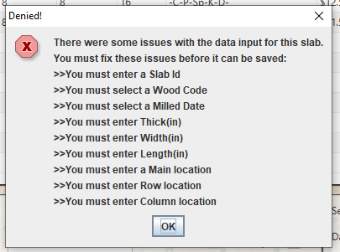

Pricing Test:

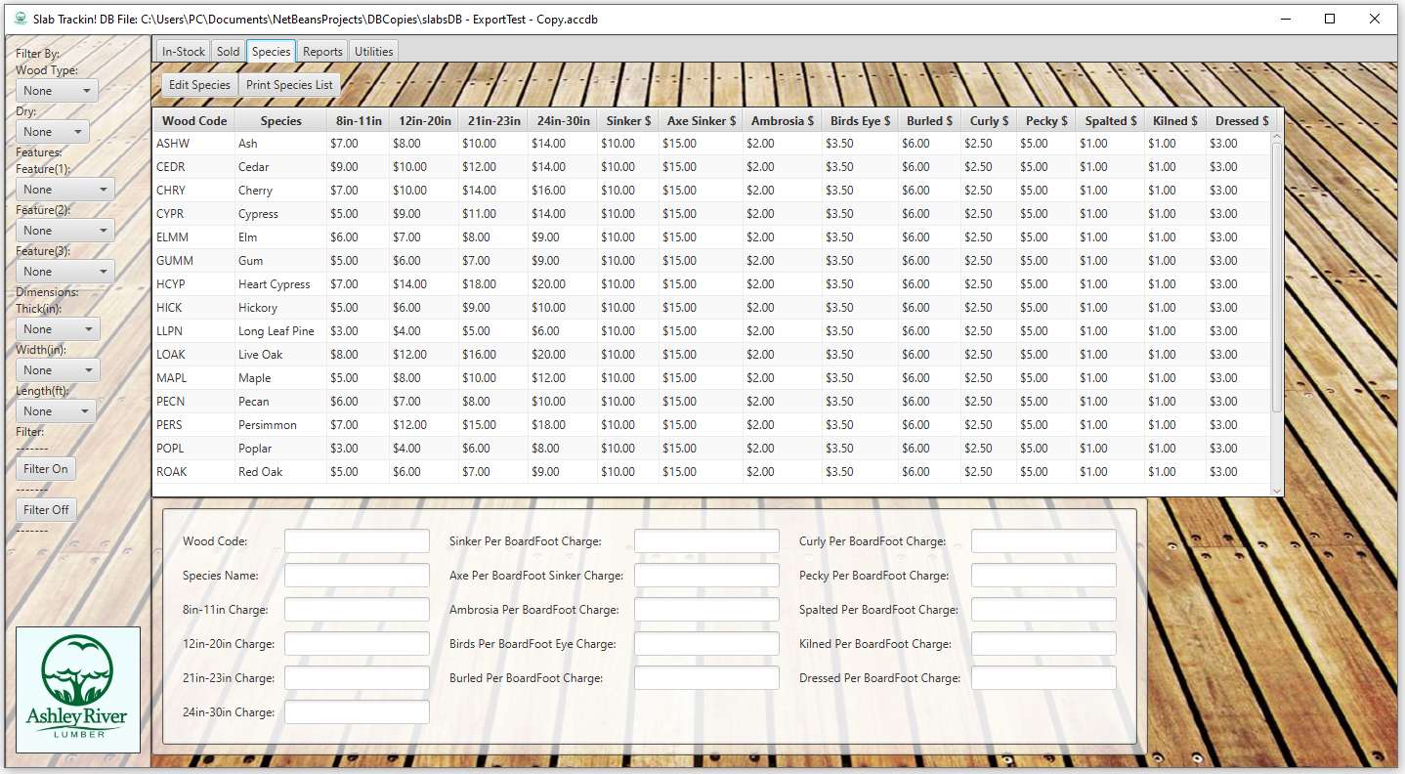

This also allowed me to test whether pricing was working correctly. The way a slab is priced is by specific species. Each species has different per board foot pricing for width. These width prices have four categories: 8in to 11in, 12in to 20in, 21in to 23 in, and 24in to 30in. This determines the base per board foot (BdFt) price. So, if an Ash slab has a width of 22 inches, then its base per board foot price is 10$. The next determinant of per board foot pricing is the features. When a feature is selected, that adds on that specific feature price. So, if the $10/BdFt Ash slab also has some Ambrosia to it then it adds on $2/BdFt, making the slab now $12/BdFt. The more features you add the higher the per board foot price. The most you can add on with features with the presently set prices is $49/BdFt. The next determinant of a slabs total price would be to take the combined width and feature price and multiply it by total slab board feet. To get this number you have multiply (thickness(inches) x width(inches) x length(feet)) then divide the result by twelve. In conclusion, for a slab that is slab that is 2” thick, 22”wide, and 12’ long, the calculation would look like this:

(2x22x12)/12= 44 BdFt

Next, to get the final slab price we would multiply the total per board foot cost $12(Ash,22”,with Ambrosia) times the total board feet 44 would make the total slab $528. Success!



In-Stock Slab to Sold Slab Data Integrity Test:

My unit test for this included entering a test slabs and using the ‘sell this slab’ button to move it to the Sold table. I wanted to make sure that all the data was the same when I did this.  My test slabs are Slab Id 0000000001 - 0000000008 in the In-Stock slabs table. A successful test will show that all data remains the same after the slabs have been moved to the Sold Slabs table.

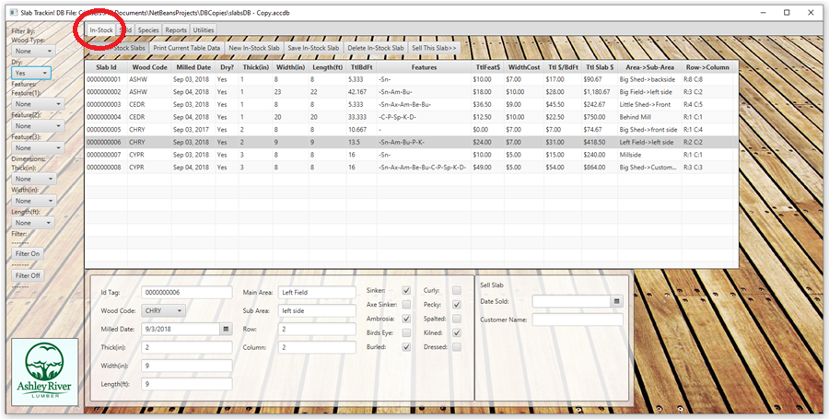

Success! All table data stayed the same when the slabs were sold:

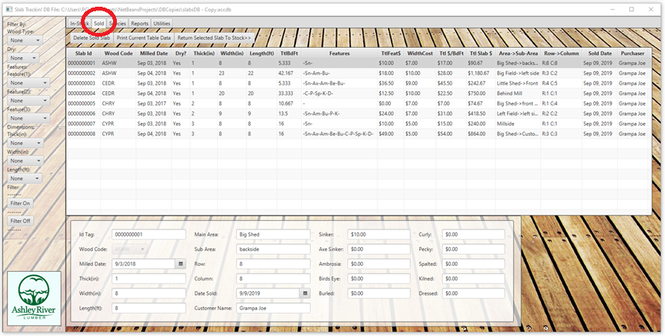

Sold Slab to Data In-Stock Slab Integrity Test:

The Return Selected Slab To Stock button will delete the Sold slab and translate it back to an In-Stock slab. If a feature price is above 0 then it is checked in the new InStockSlab object that is made. Both InStockSlab and SoldSlab objects have the translation method. Once a Sold slab is returned, the price is recalculated and is not guaranteed to be the same. This is why the password check exists for this button but not the Sell This Slab button. Buttons that apply to specific slabs will not be visible unless a slab is selected. Buttons that have to do with editing a slab or species will not be visible unless the edit toggle buttons are on. For more detail on button behavior see the manual.

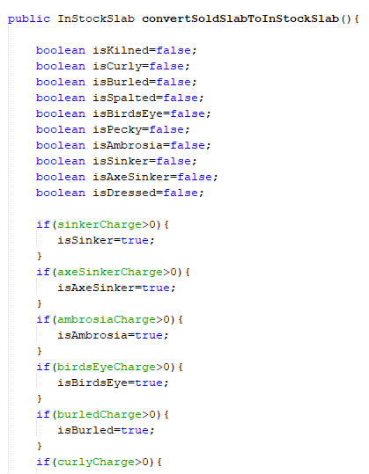

For this test, I will only move two slabs, 0000000007 & 0000000008:

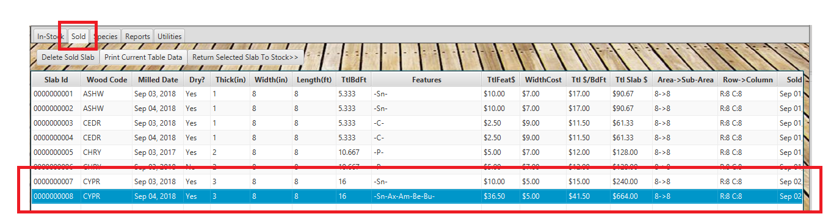

Success! All table data stayed the same when the slabs were returned:

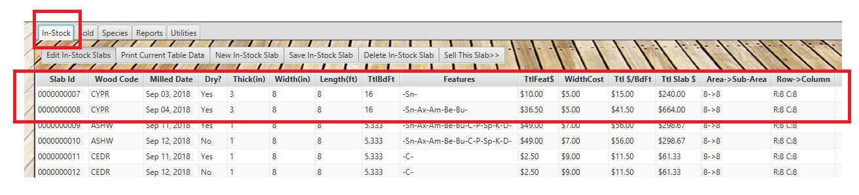

This concludes my Methodology and Unit Testing section of my Capstone Summary.